La Jolla Cave History- Prohibition in La Jolla

The seven caves of La Jolla sit at the base of the cliff side, along the waters below coast walkway. Sunny Jim's is the only cave accessible by means other than water. Most of the other caves are only visited by kayak, or swimming. For over 100 years the caves of the La Jolla have been an attraction for people visiting the area.
Approximately 10 to 15 feet north of the present Cave Store along the northwestern entrance of the Coast Walkway stood the once called cave curio store. Smugglers once used this cave to bring in illegal Chinese and other immigrants, and contraband whiskey. Nationwide prohibition was ratified in 1920, and Federal Prohibition agents were given the task of enforcing the law. Prohibition is also referred to as part of the Temperance movement, which wanted to make alcohol illegal. The humanitarian effort stated that the goal was to better the lives of the common people.
One of the early residents of La Jolla was a German-born artist named Gustauf Schultz. He moved to La Jolla with the intention of opening an art gallery to support his retirement, however, his artwork was stolen before he could open his gallery. In addition to being an artist he was also a geologist and a mining engineer. He hired two men to dig a tunnel down to the caves in the cliffside below where his gallery would have been. The 145-foot tunnel was dug entirely by hand and opened in 1903. There were no stairs in those days. Today you can easily walk down the steps inside the cave store, to visit the inside of the cave. The 145 steps, hand-rail and the wooded platform at the bottom were added in 1920. Visit our Cave Store page for more information.

The property was purchased from Miss Anna Held, who started the Green Dragon colony. The colony was settled by fellow German-Americans who had gravitated to the oceanfront village of La Jolla, obviously now we can see why.

SD's Prohibition Scandal: From Hooch to Hoosegow
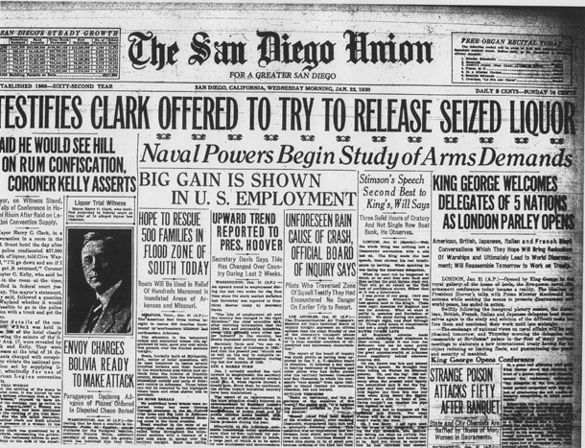 by Randy Dotinga
Downtown San Diego, home to 19th-century saloons and today's Gaslamp Quarter, has always liked to keep visitors well lubricated.
The Prohibition era dried things up, but cops would often look the other way if a big convention was in town. The law was the law, of course. But soused tourists liked to spend money, and a wink and a nod wouldn't hurt anyone unless someone squealed.
In the waning days of the Roaring Twenties, someone did.
The resulting scandal put the mayor and police chief on the hot seat, embarrassed the American Legion and sent a bunch of men into the welcoming arms of the county jail warden. It's a story of crime and alleged corruption that's not unlike from those told in the widely acclaimed new Ken Burns/PBS documentary about the violent and surprisingly boozy years of Prohibition.
The tale begins in August 1929, nine years into Prohibition's almost-total ban on the manufacture and sale of alcohol. The American Legion, a veterans organization formed 10 years earlier after World War I, was coming to town for a convention.
The ex-soldiers wanted to imbibe, so an "irrigation committee" was formed. According to testimony, its purpose was to see that the "boys got good liquor."
It's not clear where they got it, but it wasn't impossible to find booze in or near San Diego at the time. Mexico — Tijuana and Agua Caliente in particular — were hot spots for liquor seekers, and rumrunners brought liquor from Canada and elsewhere to the West Coast via the sea. (In 1930, in fact, a speed boat would be found in Coronado with a cargo of 138 cases of booze and two dead rumrunners.)
The committee contacted a bootlegger and set up a deal for 3,500-4,000 gallons of liquor, according to testimony. The bootlegger assumed the San Diego cops wouldn't make a fuss. "I knew it was customary for the authorities to relent at times of conventions," he later testified.
That may have been true. Other testimony suggested that both the San Diego mayor and the police chief indicated they wouldn't interfere. "I am not going to bother the conventions, particularly the American Legion convention," Police Chief Arthur Hill allegedly told a member of the liquor ring.
In this case, though, things didn't go according to plan.
"Somebody got sore" at the American Legion, according to testimony, and tipped off a cop about a cache of liquor in a building on Seventh Avenue. The policeman launched a raid — it wasn't clear what role, if any, the police chief played — and the gig was up.
The agents confiscated $27,000 worth of liquor, equal to more than $340,000 today. And it wasn't just any old rotgut: a chemist later found it was 44-58 percent alcohol, the equivalent of up to 116 proof, enough to make a legionnaire forget Prohibition (or the Great War, for that matter) ever existed.
Then things got even more complicated. The day after the raid, a confab was held in room 209 at the U.S. Grant Hotel, featuring some of the liquor ring members along with the mayor, the police chief and, for some reason, the coroner. The topic at hand: What now?
According to the coroner, Mayor Harry C. Clark had a plan to restore the booze to its proper place: "I'll go down and see if I can get it returned." This allegedly came after a reminder about who had helped pay for his campaign.
The booze was not returned. The authorities would keep it, although alcohol from somewhere reportedly resulted in several attendees at the Grant Hotel meeting being "stewed."
But the mayor's alleged words would return to haunt him. Months later, the coroner would recount them in front of a federal jury that was pondering the fate of 14 alleged members of the liquor ring. The coroner's charge against the mayor — that Clark tried to get the booze back where he thought it belonged — would be blared across the top of the front page of The San Diego Union.
Ultimately, the federal prosecutors won. A jury convicted six of nine defendants charged in the liquor ring. Five more pleaded guilty, including the bootlegger. The convicted men were each sentenced to up to six months in county jail.
The mayor and the police chief weren't charged. In fact, the federal prosecutor went out of the way to suggest they were being wrongly maligned.
After the mess was all over, everybody involved surely needed a stiff drink. But it was surely tougher to get one in a town that had learned a hard lesson about the risks of hospitality.
Note: This story is based on news accounts from the time in The San Diego Union.

