( ILLUSTRATE THIS PAGE WITH YOU AND THE PLACES IN THE WORLD THAT YOU WOULD LIKE TO VISIT)

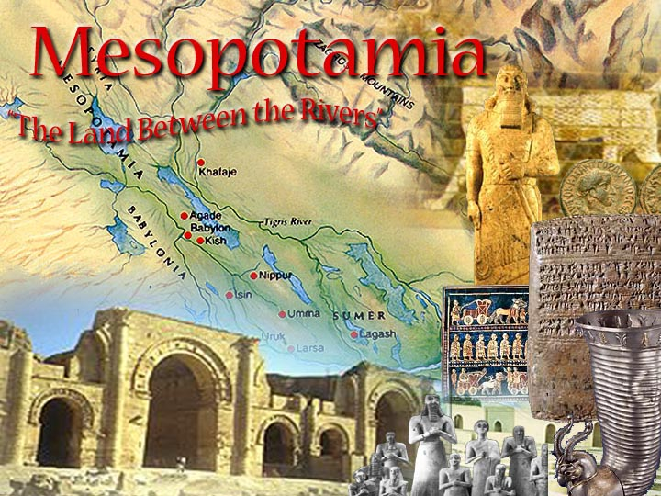
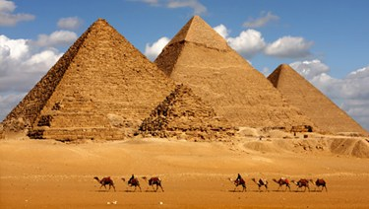

TABLE OF CONTENTS
- SYLLABUS (PAGE 1&2)
- ME AND THE WORLD (ILLUSTRATED PAGE) (3)
- UNIT ONE (COVER PAGE) (4)
- TABLE OF CONTENTS (5)
- POWER POINT WHO I AM (6)
- POWER POINT MESOPOTAMIA (6B)
- CUNEIFORM HANDOUT (7)
- CUNEIFORM NAME (YOUR NAME) (7B)
- HAMMURABI CODE ASSIGNMENT HANDOUT & VOCABULARY (PG 8)
- ZIGGURAT MODEL
- PPT DESTINY AND CHOICE (8B OR 9)
- REFLECTION ON MESOPOTAMIA (WRITE 1 WHOLE PAGE) USE STANDARDS AND NOTES . UNIT ENDS (PG 10)

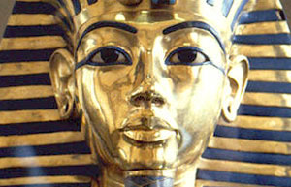
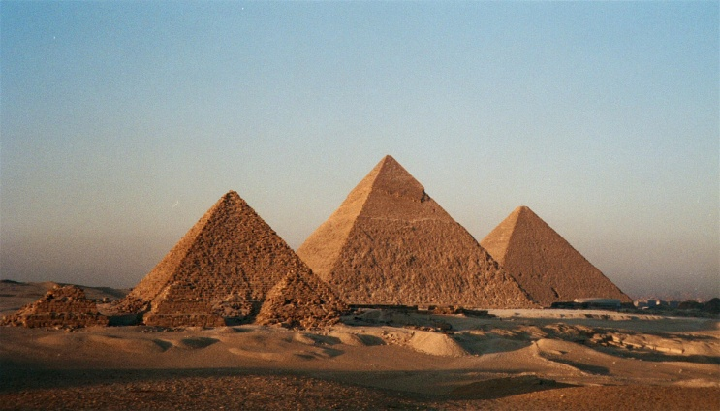

- NEW UNIT ON EGYPT -11
- HANDOUT OF THE ALPHABET 11B
- HANDOUT OF THE GODS NAMES AND FUNCTIONS 12B
- PPT ON ANCIENT EGYPT – 13PG
- EGYPTIAN GODS PG 14
- HANDOUT ON THE AMERICAN BOOK OF THE DEAD ACTIVITY
- END OF UNIT B REFLECTION

