How can a person attain true happiness?

Activity 1: Give One, Get One

List two to three ways that people can achieve true happiness. Then find at least two other people in class, and write down their ideas. Have each person initial next to his or her idea. Then report at least one idea from your list to the whole class.

Brainstorm—List two to three ways that people can achieve true happiness.
1. __________________________________________________________________________
2. __________________________________________________________________________
3. __________________________________________________________________________
4. __________________________________________________________________________
5. __________________________________________________________________________

[Classmate’s name] pointed out that . . .
[Classmate’s name] claimed that . . .

For example: Luis pointed out that happiness is something that can be achieved by earning a lot of money.

Rewrite one idea using the sentence starter.
Happiness can be achieved by
______________________________________________________________________________________________________________________________________________________________________________________________________________________________________________________________ .

Activity 2: Quickwrite
Take a look at the following graph in which a total of 66 youth rated what they believe makes or would make them happy. After considering the graph, agree or disagree with the statement that people can determine their own happiness.
Happiness Survey Results: A total of 66 youth (35 Males and 31 Females), aged 11-19, were surveyed using questionnaires. Youth were asked to rate 16 items on a scale of 1 to 16, 1 being that which makes, or would make them most happy and 16 being that which makes them least happy. The following graph indicates the average results for each item:
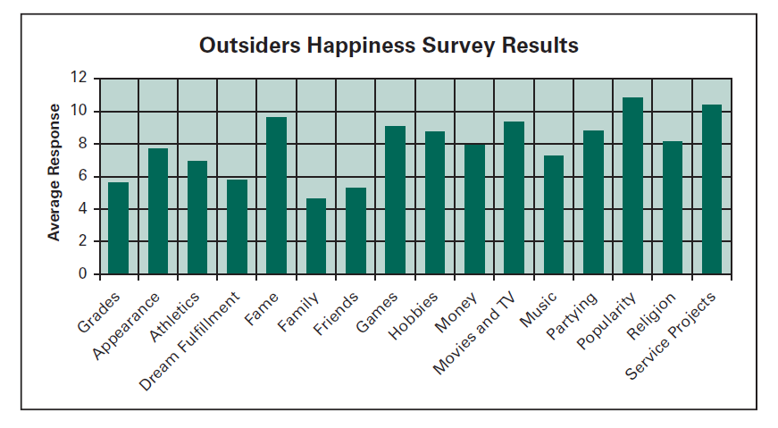
Overall, youth indicated that family (with an average response of 4.70) made them most happy, while popularity (average response of 10.80) made them least happy. Friends (average of 5.35) and grades (average of 5.67) were the second and third most influential.
Can people determine their own happiness? Explain.
_________________________________________________________________________________________________________________________________________________________________________________________________________________________________________________________________________________________________________________________________________________________________________________________________________________________________________________________________________________________________________________________________________________________________
When you have finished writing, exchange responses with your partner. Write a response to what your partner wrote. You may agree or disagree, ask a question, or suggest additional ideas. When you have both finished, your teacher will share some of your joint responses with the whole class.
Response by ______________________________ (Name of responder)
______________________________________________________________________________________________________________________________________________________________________________________________________________________________________________________________________________________________________________________________________________________________________________________________________

