“Settling the West” Homework Assignment
Contributor to the West | Explain: their importance and their contributions to the West
1) Native Americans p.202-208
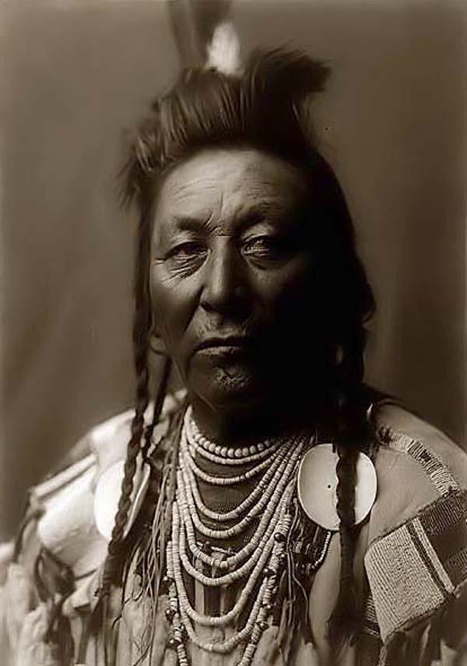
2) Captain Custer p. 206
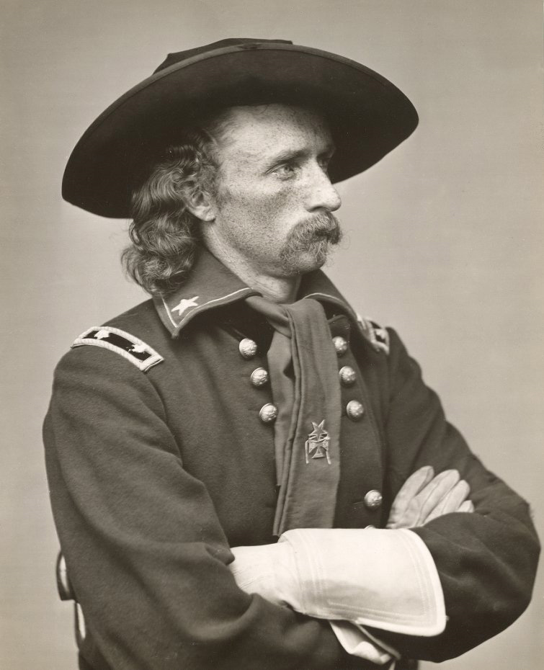
3) Vaquero p. 208

4) Miner p. 212-213
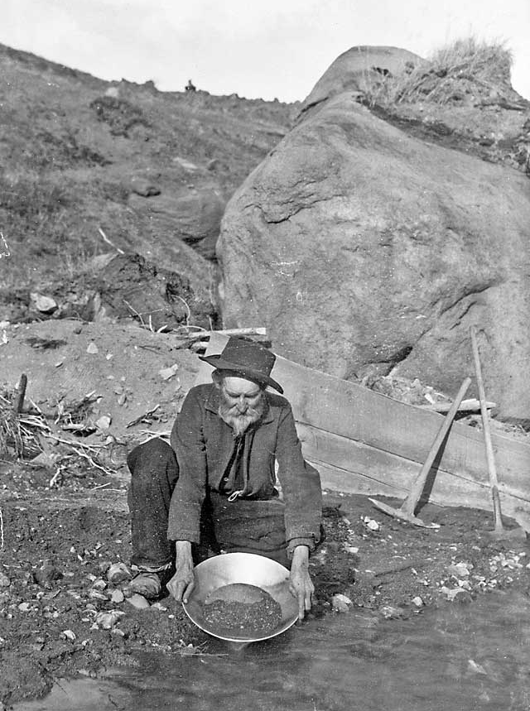
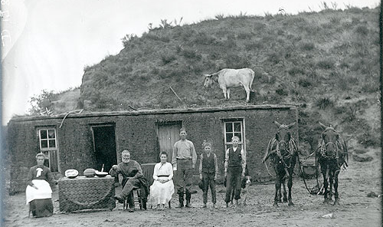
5) Settler p. 214-217
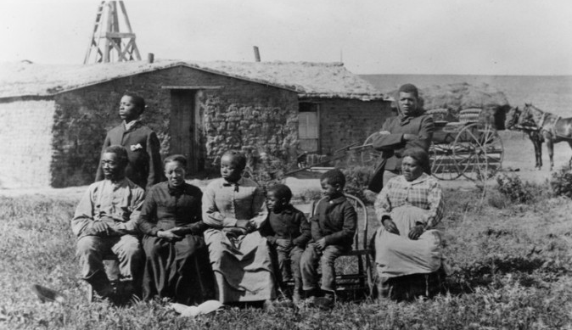
6) Exoduster p. 215-217

7) Farmers p. 218
