Issues of economic development LOTS TO HOTS
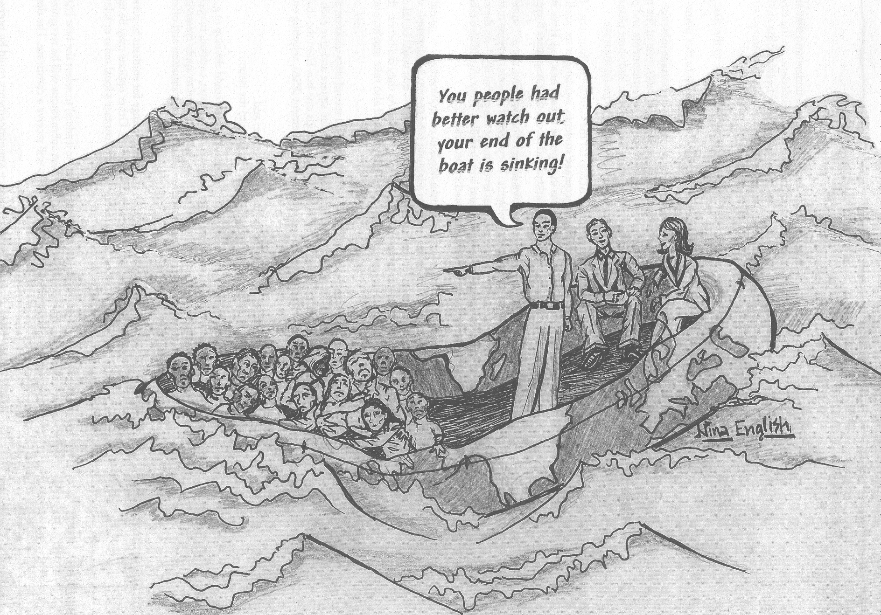
1. What does the boat represent? How many people are on the right side of the boat?

2. The people in the boat represent the “rich” and the “poor.” Which is which?

3. How can you tell?

4. What is the general mood of the people on the right? on the left?

5. Is the ocean a problem or a solution for the people in the boat?

6. Who is in danger – the people on the left, the right, or both?

7. What could the people do to stabilize the boat somewhat?

8. The sea represents global issues which are out of the control of the people in the boat. What could some of these issues be?

9. Is there anything that could cause any of the people on the right to involuntarily join the people on the left?

10. Why should the people on the right be more nervous than they appear?

11. Why is the statement the man is making ironic?

