
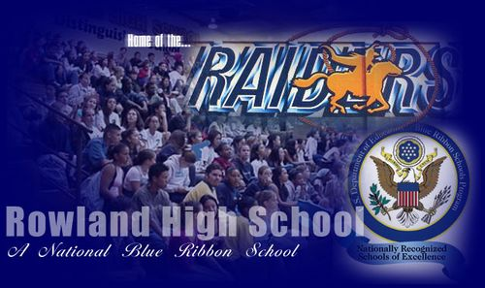
Classroom Management Plan
ROP Class: ProStart II
Room: JAR Teacher: Mrs. Warren

Welcome to ProStart II ROP course! This course is an in-depth look at food production, preparation, customer service, and teamwork skills in preparation for employment and a chance to develop and grow as a student. As a class, our general goals/purposes are:
• Continue to apply skills learned in math, english, social science, and science as found in the area of restaurant occupations, hospitality, foods and nutrition.
• Prepare foods that are nutritious and delicious.
• Learn safety and sanitation techniques to assure quality food service.
• Learn how to work cooperatively with others in the completion of laboratory and group work.
• Explore career opportunities in the area of Food Service and Hospitality.
• Learn skills that will enable students to gain employment in the area of Food Service and Hospitality.
• Gain experience in food service through the JAR and the community.
If you or your parents have concerns or questions about the class, please let me know. I am looking forward to collaborating, expanding, and even learning from you as a student. I am looking forward to a productive year at Rowland High School and I am glad to have you in my class.

In order for optimum learning to be attained, the following expectations and procedures have been established:
A. Six Common Expectations for all ROP Students:
1. BE PROMPT – be on time and where you are supposed to be
2. BE PREPARED – have all required materials needed for class and be on task
3. BE POLITE – respect the rights, responsibility, and property of others
4. BE POSITIVE – strive for excellence, always do your best and know you can be successful
5. BE PURPOSEFUL – make what you do valuable to your personal growth and goals
6. BE PRESENT—pay attention to the information presented and listen to gain understanding

Ask for help when needed! If you have any special needs or concerns, please see me and let me know how I can assist you in being successful in this ROP class.

B. Class Procedures:

- How do I know what is expected of me during class?
- Success in all courses is more often determined by your attitude and work ethic, rather than your ability; therefore, I expect everyone to have a positive attitude and be willing to work for the entire class period.
- Respect for others is important in the classroom, as well as in life. I expect you to address me with respect, look at me and listen while I am talking. In return, I will do the same for you.
- All behavior will be consistent with the rules of Rowland High School.
- Any activity that will distract from classroom learning will not be permitted.
- No unnecessary noise or talking during class.
- No grooming in class. (This includes hair combing and make-up)
- Do not put your head down on your desk at any time.
- Drinks in a sealed container are acceptable to have in class, as long as you clean up after yourself.
* If you abuse the privilege of drinks in the classroom you will lose it.
- Electronic devices and ear buds are NOT allowed in class (Unless an assignment calls for it)
- Turn cell phones, MP3’s, and games off when you enter class. I will take them away, lock them up in a safe, and will only give them back on Friday, the following Monday, or to a parent.

C. Disciplinary Procedure:
If you choose to disrupt our learning environment, you will be held accountable for your behavior through our disciplinary procedure. This procedure will limit disruptions during the class period, take responsibility for your actions, and provide the best learning environment for all students. When you choose not to follow rules and procedures, the following consequences are put into effect;

Step 1: Intervention (infraction logged and conference with students)
Step 2: Intervention (infraction logged and communication with parent)
Step 3: Intervention (infraction logged and detention assigned)
Step 4: Referral to Mr. Perez
Teachers have the right to skip to step four depending on the severity of the infraction and repeated infractions by students.

D. Plagiarism Procedure:
All material that you, the student, complete and turn in for this course will be through your own efforts and not someone else’s. If you use another’s work, properly document its use and the originator’s name. Do not give information to another student to copy or use another student’s work to complete your own assignments. Exceptions to this rule may be given by me when appropriate such as working with a partner or in a group; but only when I make this assignment. Plagiarism will result in a zero on the assignment for both parties and repeated violations will result in disciplinary action.

E. Grades
1. All assignments will be assigned a point value and all points are cumulative for the entire semester. Grades will be determined by percentages per school policy.
2. All work should be turned in on time. Late work is accepted only with a valid excused absence, but points will be deducted.
3. It is the student’s responsibility to ask the instructor for assignment when absent. Students or parents may get class assignments by calling 626-965-3448 ext. 3357, between 8:00 a.m.-3:00 p.m. or email me at dwarren@rowland.k12.ca.us
4. Each student is expected to keep all course materials. Keeping all course material is important because the exams are comprehensive and will require review of all items covered.
5. Projects will be periodically assigned. The times required to complete the projects will vary, depending on the complexity of the assignment.
6. Students will have a limited opportunity for extra-credit on special assignments and through working at lunch throughout the year. They will be announced whenever possible.
7. The grading scale breakdown in this class will be:
In-Class Assignments 30%
Homework 20%
Test/Quizzes 25%
Class Participation 25%
8. The grading scale is as follows:
A 90-100
B 80-89
C 70-79
D 60-69
F 59 and below

Please feel free to contact me at 626-965-3448 ext. 3357 or dwarren@rowland.k12.ca.us whenever you have questions regarding your son/daughter or if something happens at home that you feel might interfere with the learning process. If an email is sent, I will attempt to return emails within 48 hours. In addition, with prior notice, I will be available for conferences daily from 3:00 p.m.-3:30 p.m. I also have a webpage on Rowland’s school website http://www.rowlandhs.org this is a place where you can check assignments as well as homework. Click on Staff Directory, scroll down and click on Mrs. Danielle Warren. Also visit our class on Facebook, The Golden JAR-Mrs. Warren

Sincerely,

Danielle A. Warren
Student Last Name: _____________________ First ________________________ Per. _____________

PLEASE SIGN BELOW AND HAVE YOUR PARENTS SIGN.
Be sure you know and understand this classroom management plan and photo release.

I (print your name) ____________________________________________________________have
read and understand the classroom management plan for Mrs. Warren’s ROP classroom.

____________________________________________________________________________
Student Name (Print) Student Signature Date
____________________________________________________________________________
Parent Name (Print) Parent Signature Date

Dear Parent or Guardian:
I look forward to an exciting year of developing your student into a successful learner. When we work together as a team, the student is more successful; therefore, I would like to suggest a few things you can do to help:
1. Please read the Classroom Management Plan.
2. Please check daily to be sure that your student is keeping up with all course work.
3. Please help your student maintain a supply of needed materials for all courses, i.e. paper, pencils, etc.
4. Please monitor dress code with and for your student.
5. Please contact me if you have any questions or would like to arrange individual help for your student.
6. Please provide an updated phone number so we may reach you in a timely fashion:

Home: _____________________ Cell: ______________________ Email: ________________________

As a professional educator, I have your child’s best interest at heart and I will ensure that your child receives the best educational experience possible.

As part of our continuing efforts to provide information regarding your child's progress and status, you can now view student information for your child from our school database using Rowland's Homelink. Through our secure server, you will be able to view your child's:

- Progress Report and Semester Grades
- Transcript
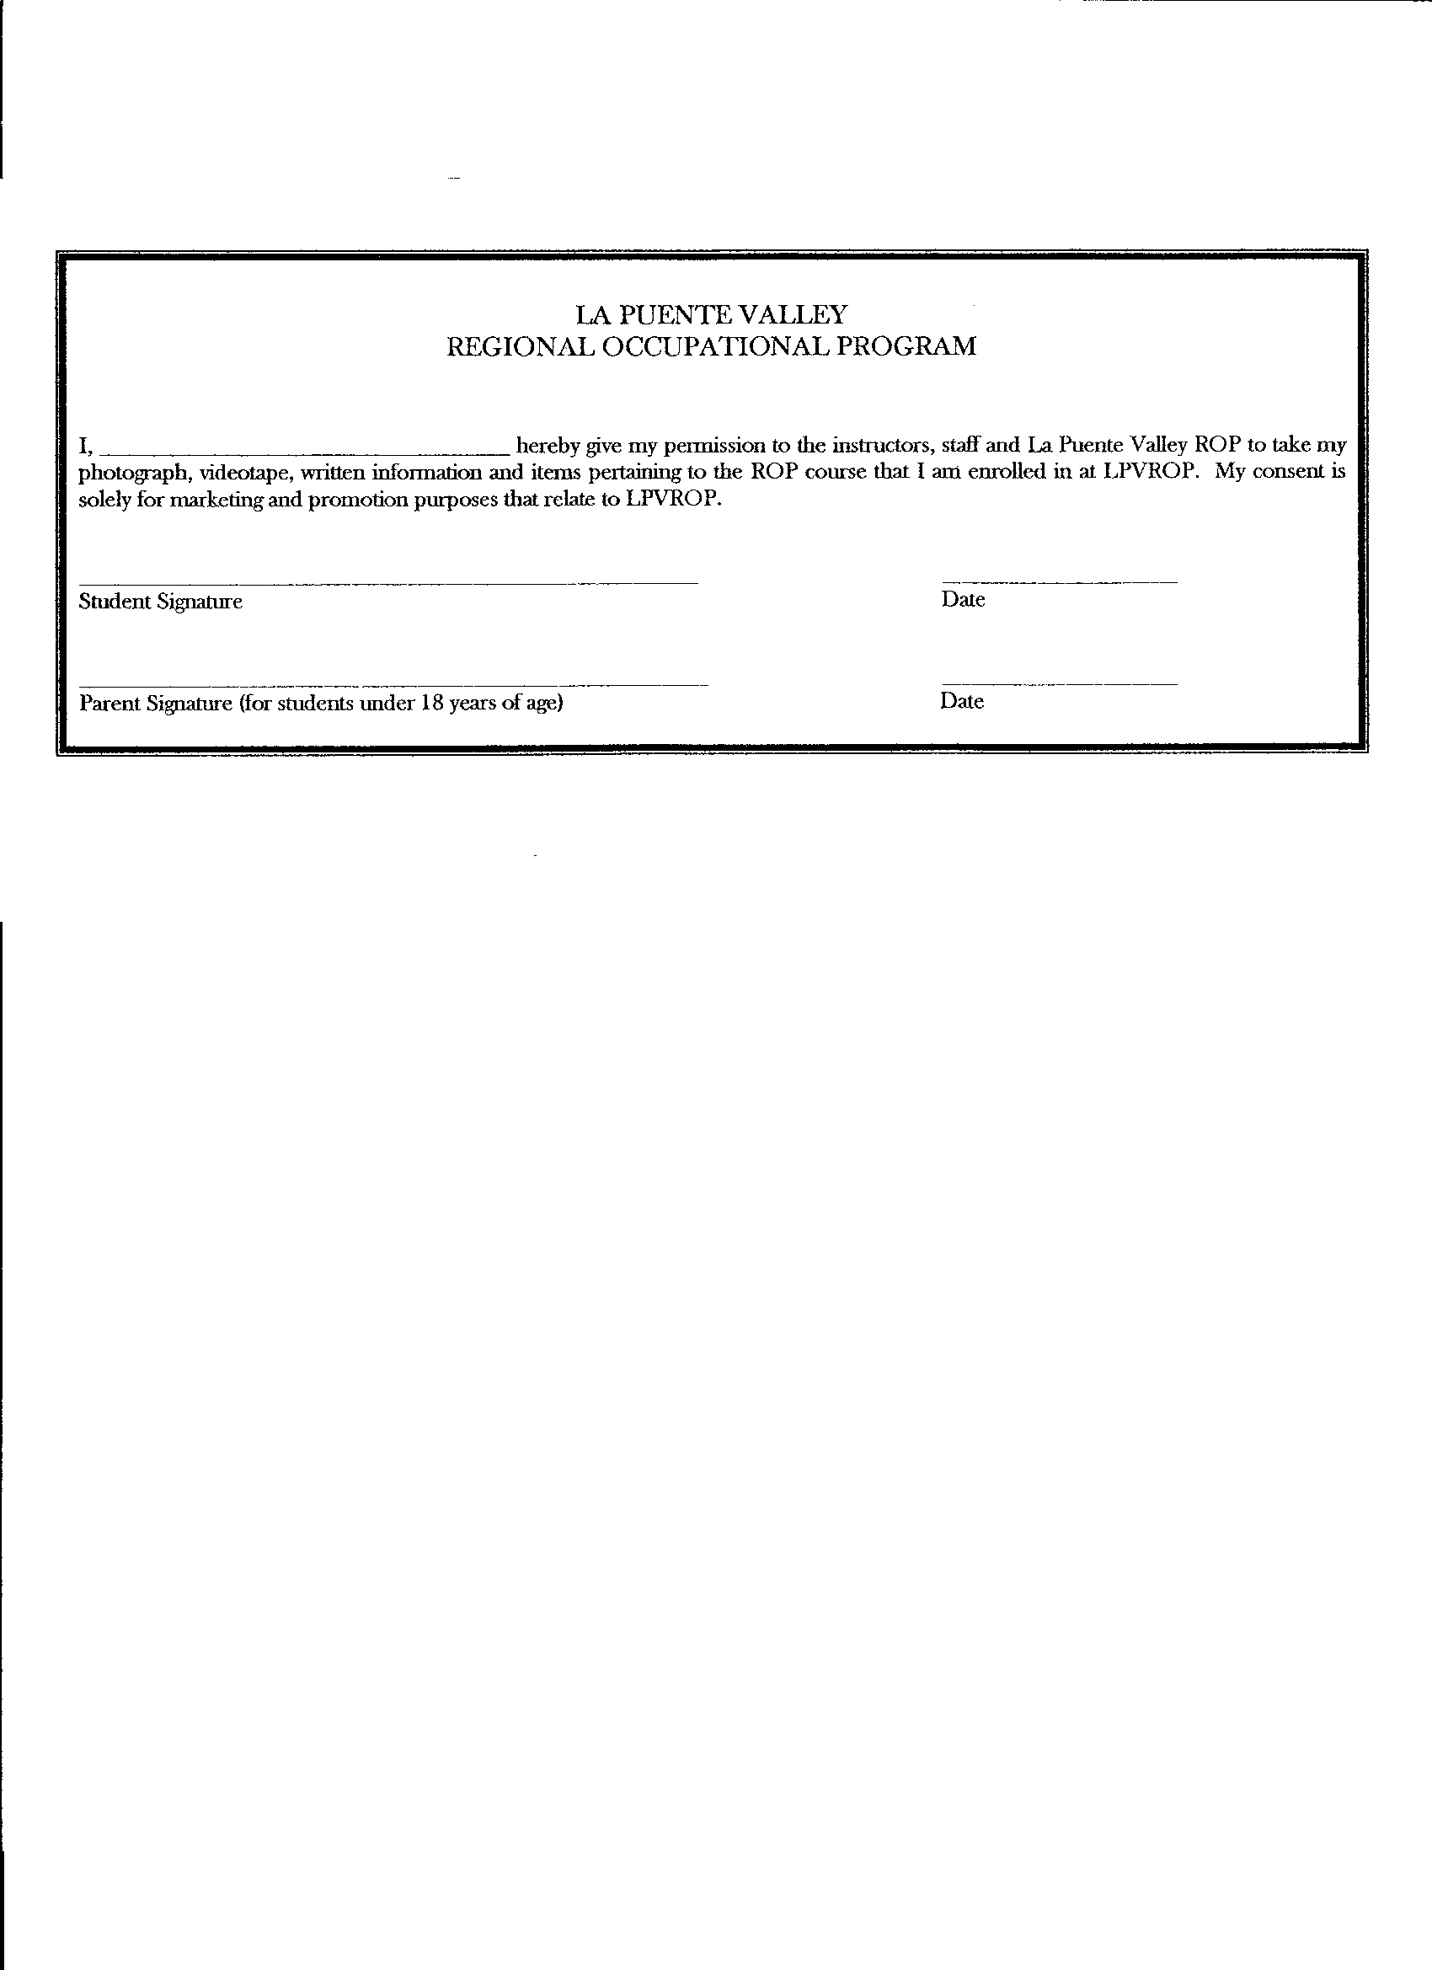
- Attendance Records
- Classes
- CAR Hours
- Graduation Status
- Emergency Contact Information
- And Much More!

You are able to access Homelink from our schools website http://rowlandhs.org
If you need help, please call us at 626-965-3448 and say you need help with Homelink and we will direct you to someone who can answer all your questions.

