Assg: ALL Name
Sheep Dissection Date pd.

Now consider all the parts you have found and how the blood flows through them. Draw a diagram of the heart and use red and blue arrows to show the flow of blood. Use blue for deoxygenated blood and red for oxygenated blood.
Then write out in words the path of blood. Start with the right atrium and end with the superior and inferior vena cava .

Your steps written out… | Your drawing with arrows:
Label the external anatomy:  - ___________________________  - ___________________________  - ___________________________  - ___________________________  - ___________________________  - ___________________________ | 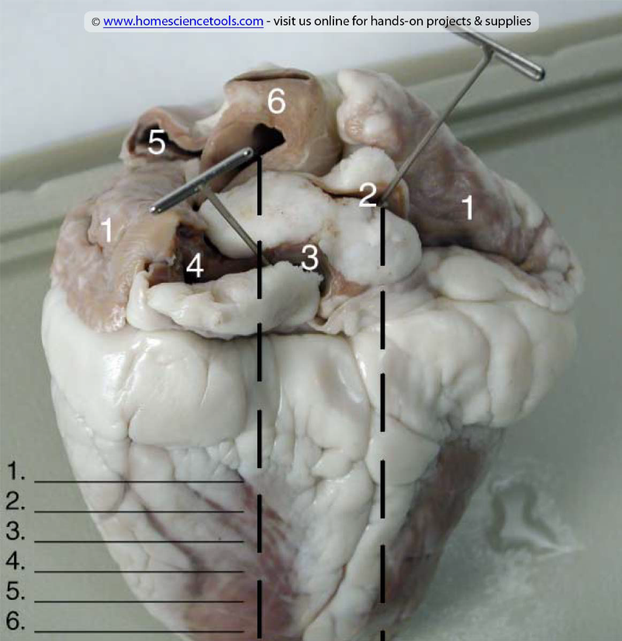
Label the internal anatomy (right side) going from left to right  - ___________________________  - ___________________________  - ___________________________  - ___________________________  - ___________________________  - ___________________________  - ___________________________ | 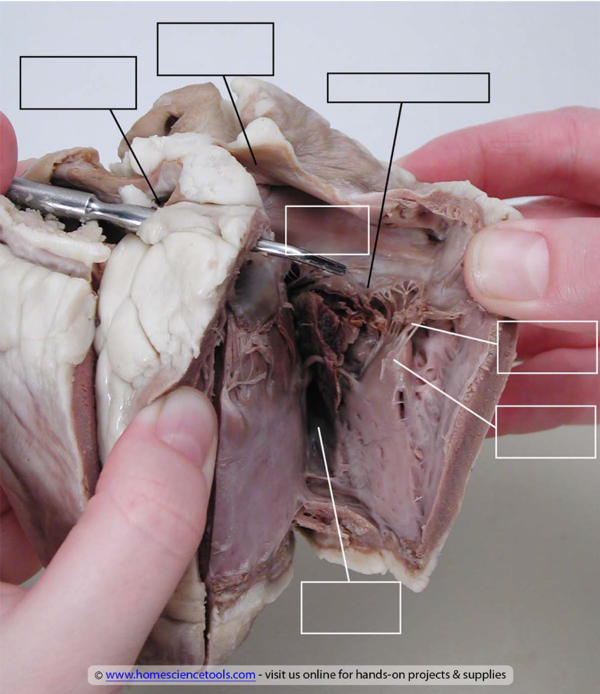
Label the internal anatomy (left side) going from left to right  - ___________________________  - ___________________________  - ___________________________  - ___________________________  - ___________________________  - ___________________________ | 