CHAPTER 18 SUMMARY – PAGE 474
SECTION 18-1 RENEWABLE ENERGY TODAY  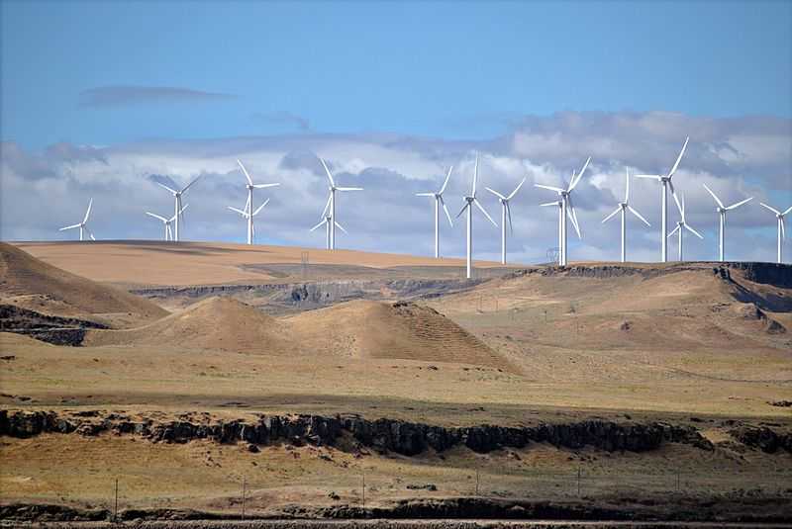 | SECTION 18-2 DEVELOPING ENERGY TECHNOLOGIES  

CHAPTER 18 SUMMARY – PAGE 474
SECTION 18-1 RENEWABLE ENERGY TODAY | SECTION 18-2 DEVELOPING ENERGY TECHNOLOGIES

CHAPTER 18 SUMMARY – PAGE 474
SECTION 18-1 RENEWABLE ENERGY TODAY | SECTION 18-2 DEVELOPING ENERGY TECHNOLOGIES

