1 Electron-pair repulsion
The valence shell electron pair repulsion (VSEPR) model that we describe here focuses on the bonding and nonbonding electron pairs present in the outermost (“valence”) shell of an atom that connects with two or more other atoms. Like all electrons, these occupy regions of space which we can visualize as electron clouds— regions of negative electric charge, also known as orbitals— whose precise character can be left to more detailed theories.
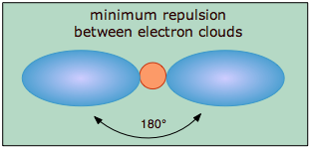
The covalent model of chemical bonding assumes that the electron pairs responsible for bonding are concentrated into the region of apace between the bonded atoms. The fundamental idea of VSEPR thoery is that these regions of negative electric charge will repel each other, causing them (and thus the chemical bonds that they form) to stay as far apart as possible. Thus the two electron clouds contained in a simple triatomic molecule AX₂ will extend out in opposite directions; an angular separation of 180° places the two bonding orbitals as far away from each other they can get. We therefore expect the two chemical bonds to extend in opposite directions, producing a linear molecule.
If the central atom also contains one or more pairs of nonbonding electrons, these additional regions of negative charge will behave very much like those associated with the bonded atoms. The orbitals containing the various bonding and nonbonding pairs in the valence shell will extend out from the central atom in directions that minimize their mutual repulsions.
If the central atom possesses partially occupied d-orbitals, it may be able to accommodate five or six electron pairs, forming what is sometimes called an “expanded octet”.

Electronegativities of the main-group elements
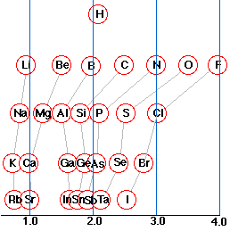
The 0-4 electronegativity scale of Pauling is the best known of several arbitrary scales of this kind. Electronegativity values are not directly observable, but are derived from measurable atomic properties properties such as ionization energy and electron affinity. The place of any atom on this scale provides a good indication of its ability to compete with another atom in attracting a shared electron pair to it, but the presence of bonds to other atoms, and of multiple- or nonbonding electron pairs may make predictions about the nature a given bond less reliable.
An atom that has a small electronegativity is said to be electropositive. As the diagram shows, the metallic elements are generally electropositive. The position of hydrogen in this regard is worth noting; although physically a nonmetal, much of its chemisry is metal-like.
Dipole moments
When non-identical atoms are joined in a covalent bond, the electron pair will be attracted more strongly to the atom that has the higher electronegativity. As a consequence, the electrons will not be shared equally; the center of the negative charges in the molecule will be displaced from the center of positive charge. Such bonds are said to be polar and to possess partial ionic character, and they may confer a polar nature on the molecule as a whole.

Electron structures involving multiple bonds
The need for double or triple bonds usually becomes apparent when you have more electrons than can be accommodated in single bonds and lone pairs. Thus in the molecule acetylene (ethyne) C₂H₂, the single electrons contributed by the hydrogen atoms can be thought of as being paired up as one component of the carbon-carbon triple bond:
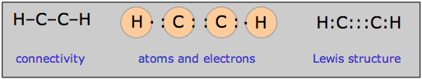

4 Multiple equivalent structures: resonance
There is a rather large class of molecules for which one has no difficulty writing Lewis structures; in fact, we can write more than one valid structure for a given molecule! Consider, for example, the nitrate ion NO₃–. We can develop a Lewis dot formula satisfying the octet rule as follows:
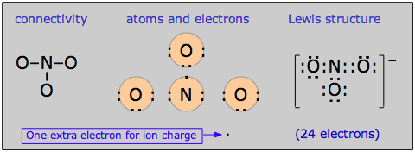
According to this structure, the ion contains two N–O single bonds and one N–O double bond. But there is no special reason to place the double bond where it is shown in the diagram above; it could equally well go in either of the other two locations. For this molecule, then, we can write three equally valid structures:
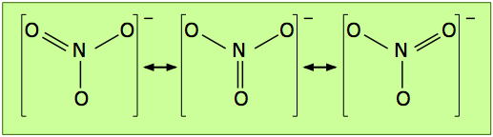
The double-ended arrows indicate that the nitrate ion is a superposition of all three structures, and this is supported by experimental evidence which shows that the three oxygen atoms are chemically identical, that all three bonds have the same length, and that the molecule has trigonal symmetry (meaning that the three oxygens are geometrically equivalent.)
The term resonance was employed to describe this phenomenon in the 1930's, before chemical bonding became better understood; the three equivalent structures shown above are known as resonance hybrids. The choice of the word "resonance" was unfortunate because it connotes the existence of some kind of dynamic effect that has led to the mistaken idea that the structure is continually alternating between the three possibilities.

